GIT Creation in Azure DevOps

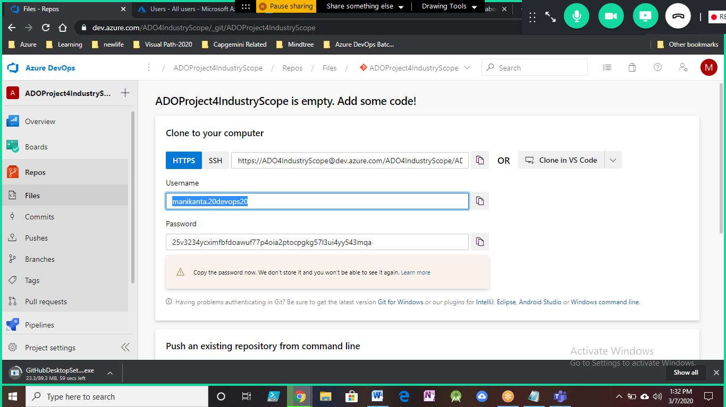

manikanta.20devops20

25v3234ycximfbfdoawuf77p4oia2ptocpgkg57l3ui4yy543mqa

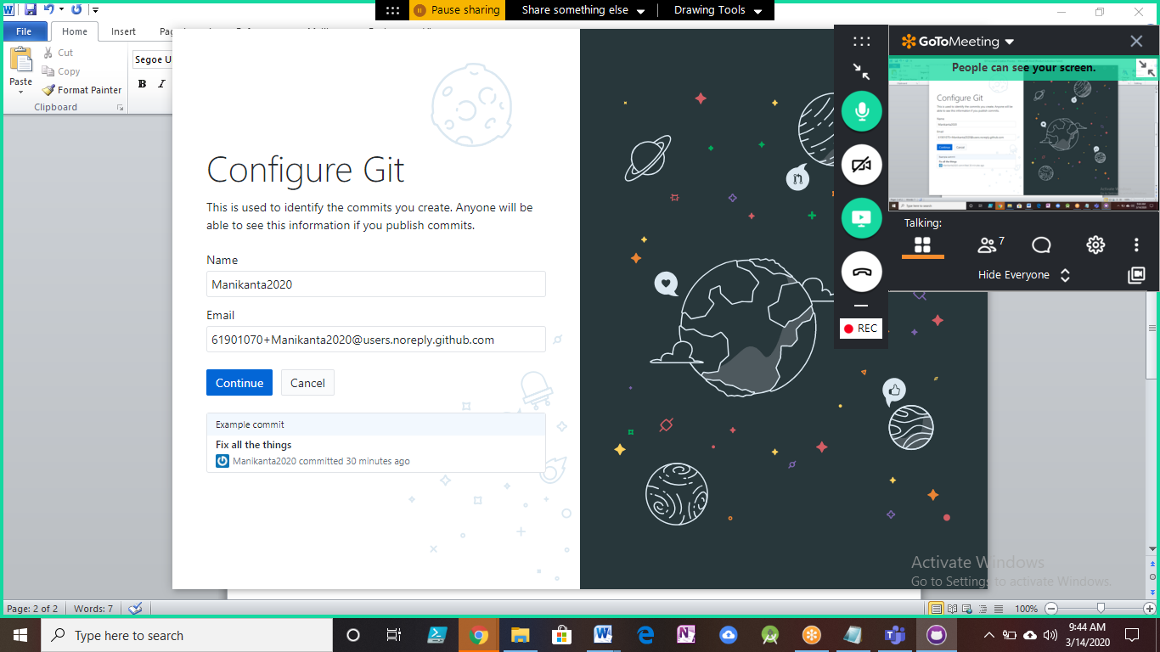

GIT Display Name is Manikanta2020

GIT Email is [61901070+Manikanta2020@users.noreply.github.com](mailto:61901070+Manikanta2020@users.noreply.github.com)

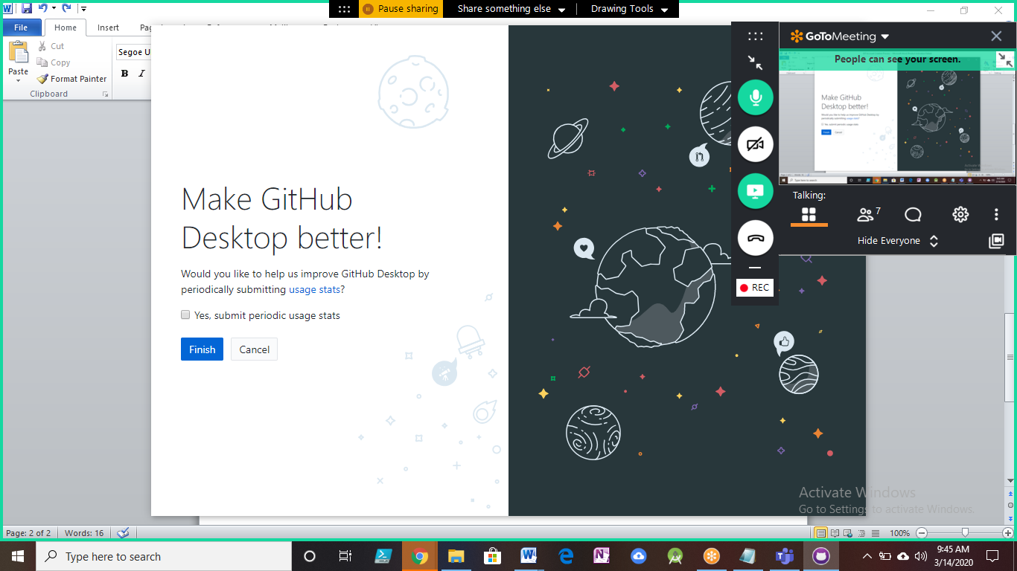

After this configured the Repositories details from GIT HUB Repositories.

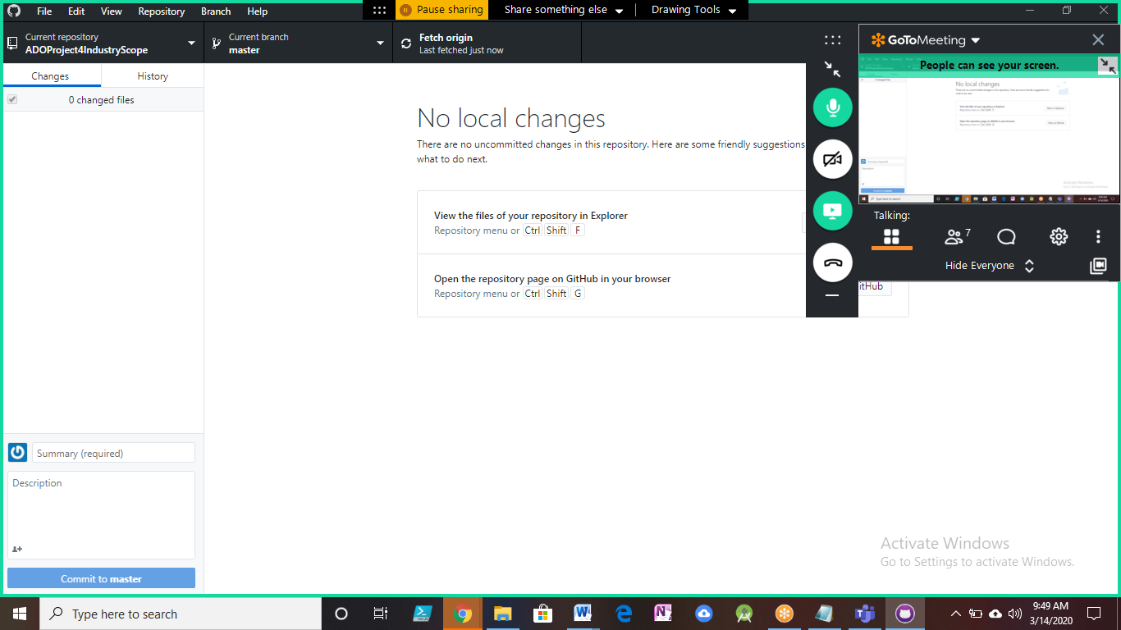

Created a new local branch with master as source branch to get the repository created for Practice Purpose.

